

**Chapter 1**

**Student name**: Khaled Abdelnaby Ahmed

**ID** : 202202016

**Subject**: web programming

**Dr**. Hajar Mohi



**Chapter 2**

**Introduction**

Our website aims to provide a remote trainer service, and within the site there are pages with many exercises and other pages with information about nutrition

The site has constant updates

**The website consists of 21 pages**

1 – Home 2 – my accont

3 - sign in 4 - Nutrition plans

5 - Amplification system 6 - Drying system 1

7- Drying system 2 8- Protein sources

9- Sources of healthy fats 10- Sources of milk and eggs

11- Sources of carbohydrates 12- call us

13- Create an account 14- privacy policy

15- terms of use 16- Abdominal muscles

17- Back muscles 18- Chest muscles

19- Shoulder muscles 20- Arm muscles

21- Leg muscles

1 – **Home**

The home page consists of the footer, header, and body

The footer contains several links to most of the pages on the site to facilitate access to the services provided by our site

The body has an explanation of the site's services, and each muscle has a button

When you click on it, the page for the muscle opens

The last part on the home page is the footer

It contains abbreviations for the links of all the mentioned muscles in the body

2 – **my accont**

This page contains information about the account owner. He is responsible for that information

Such as registration information

3 - **sign in**

This page is responsible for logging in. There must be an account and it asks for the username and password

4 - **Nutrition plans**

This page contains a list of some nutrition plans, and when you click on any plan, the page for the nutrition system opens

5 - **Amplification system**

This is the page for enlargement, which shows the number of meals and the components of each meal, and at the end of the page is the total content of the system

6 - **Drying system 1**

This is the page for drying, which shows the number of meals and the components of each meal, and at the end of the page is the total content of the system

7- **Drying system 2**

This is the page for drying 2, which shows the number of meals and the components of each meal, and at the end of the page is the total content of the system, unlike the other system.

8- **Protein sources**

This page is about protein sources in different proportions. All these proportions are for 100 grams of each type

9- **Sources of healthy fats**

This page is about sources of healthy fats in different proportions. All these proportions are for 100 grams of each type

10- **Sources of milk and eggs**

This page is about sources of milk and eggs in different proportions. All these proportions are for 100 grams of each type

11- **Sources of carbohydrates**

This page is about sources of carbohydrates in different proportions. All proportions are for 100 grams of each type.

12- **call us**

This page is for communication between the user and the owner of the page, and the page is used until the user faces any problem when using it

13- **Create an account**

This page is for creating a new account and requires some information about the user, such as name, email, and password

14- **privacy policy**

This page contains several information about the privacy policy and awareness

15- **terms of use**

This page contains several information about terms of use and awareness

16- **Abdominal muscles**

This page is specific to the abdominal muscle and contains several shapes and exercises for the target muscle

17- **Back muscles**

This page is specific to the back muscle and contains several forms and exercises for the target muscle and the auxiliary muscles

18- **Chest muscles**

This page is specific to the chest muscle and contains several forms and exercises for the target muscle and the auxiliary muscles

19- **Shoulder muscles**

This page is specific to the shoulder muscle and contains several forms and exercises for the target muscle and the auxiliary muscles

20- **Arm muscles**

This page is specific to the arm muscle and contains several forms and exercises for the target muscle and the auxiliary muscles

21- **Leg muscles**

This page is specific to the lag muscle and contains several forms and exercises for the target muscle and the auxiliary muscles

**Chapter 3**

1 – Home

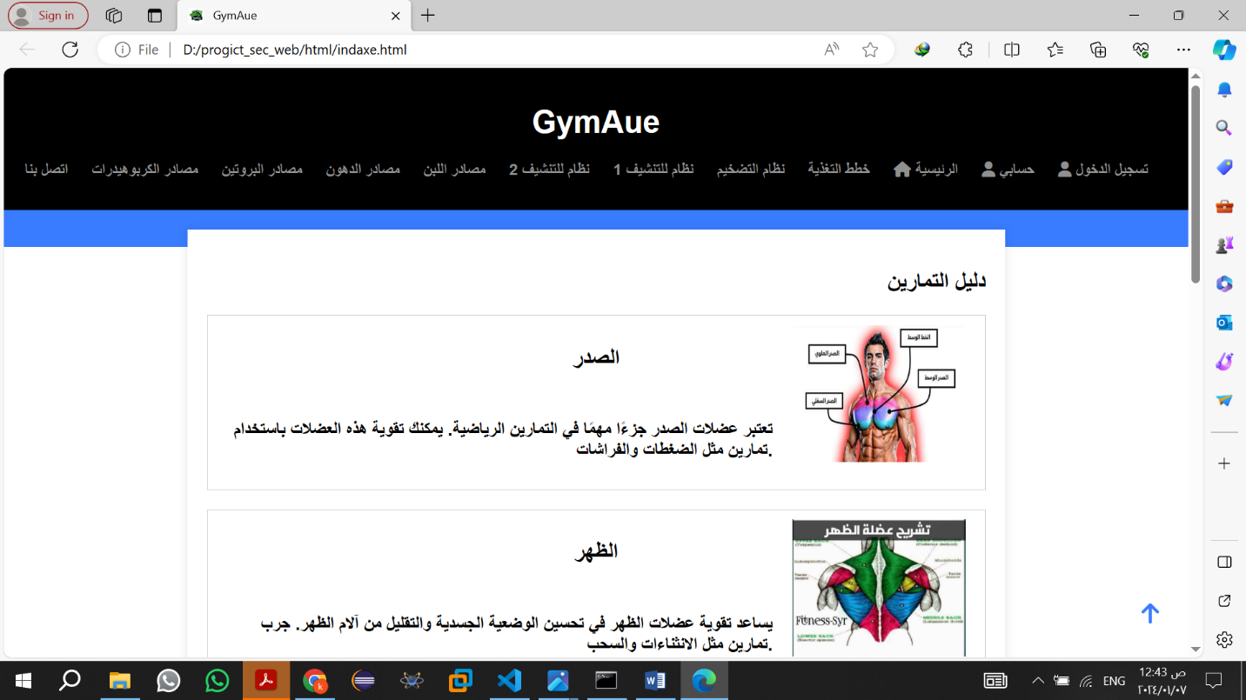

2 – my accont

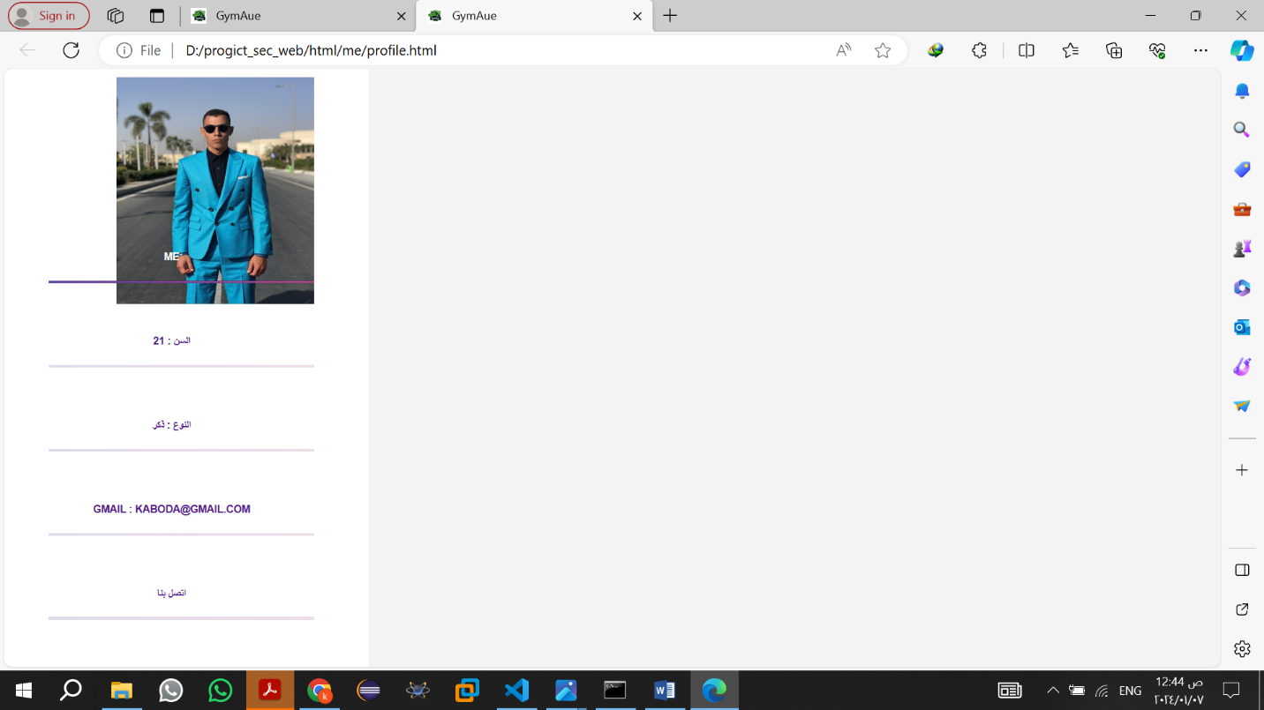

3 - sign in

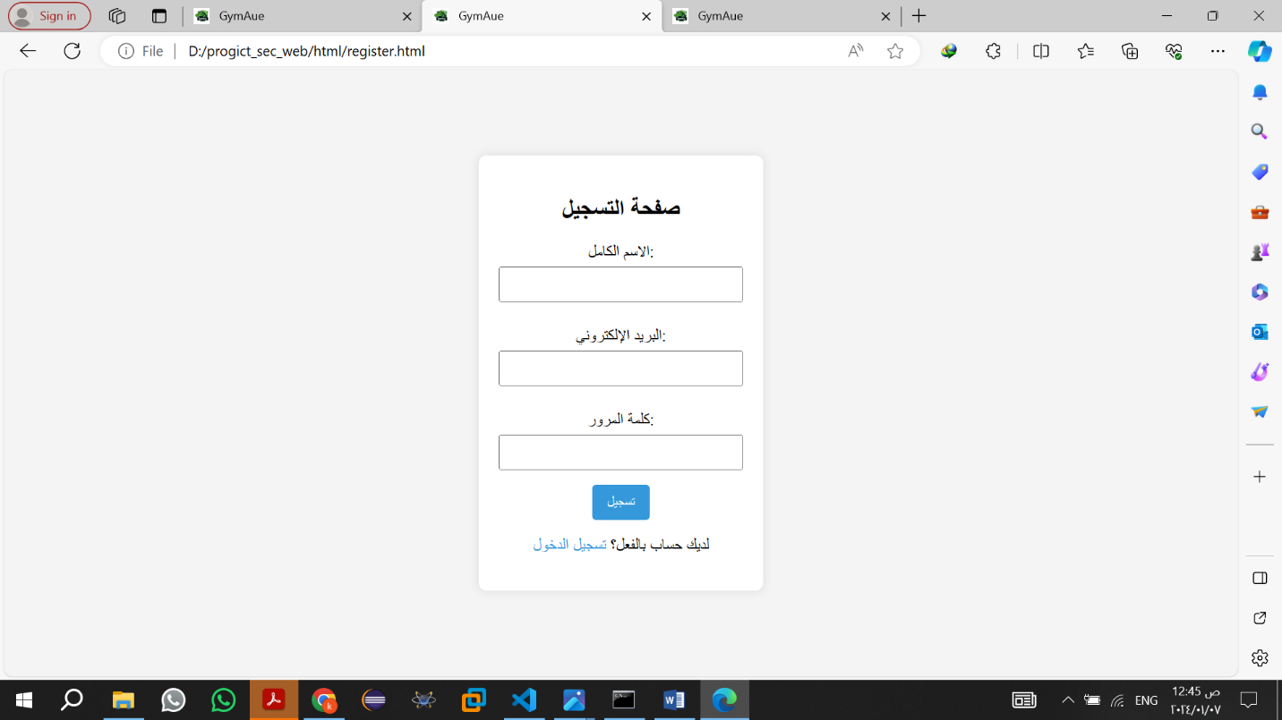

4 - Nutrition plans

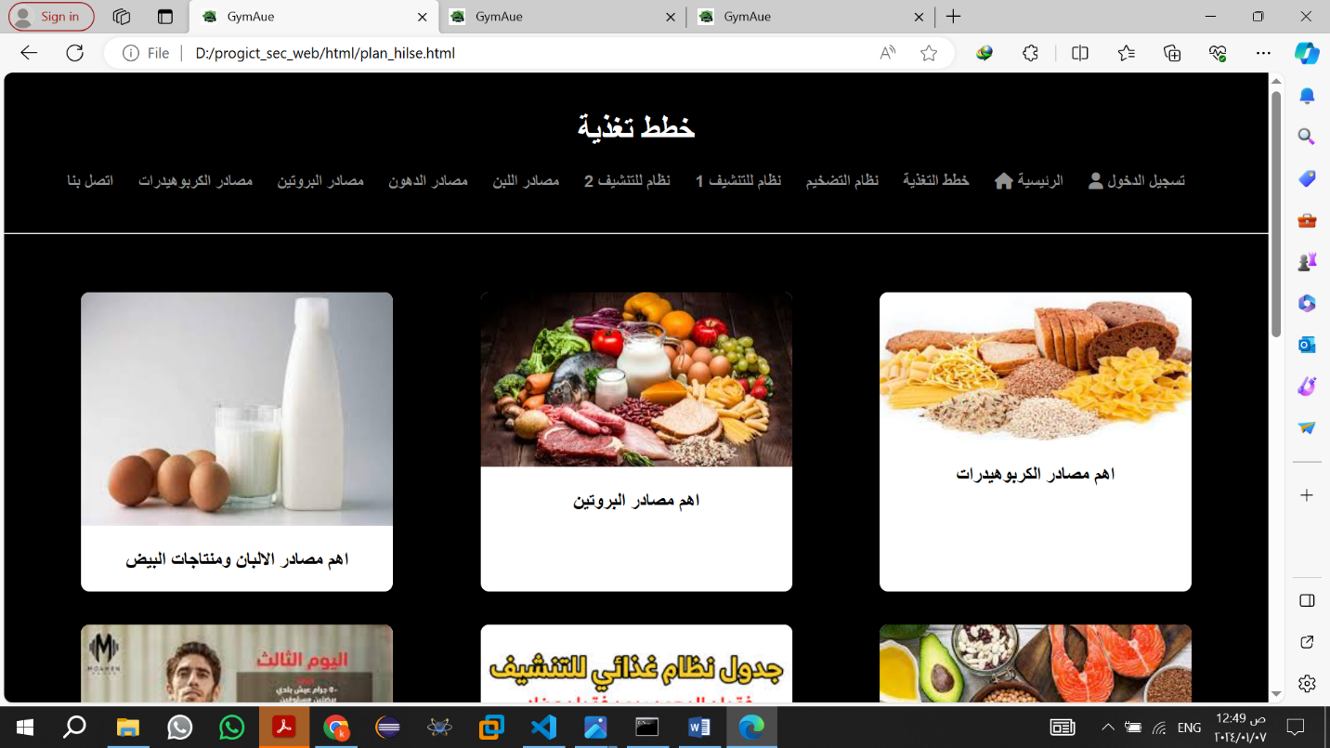

5 - Amplification system

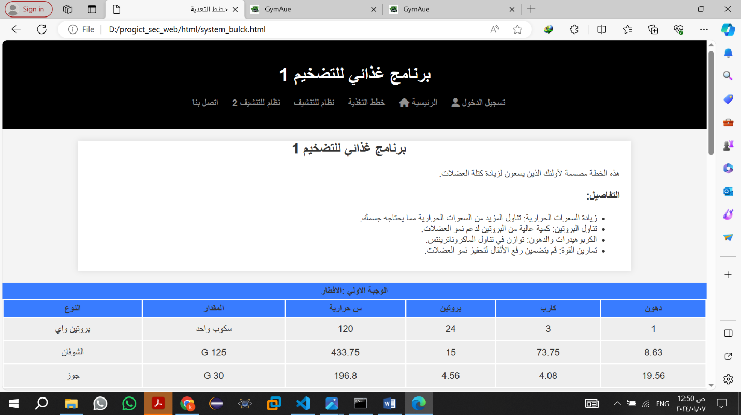

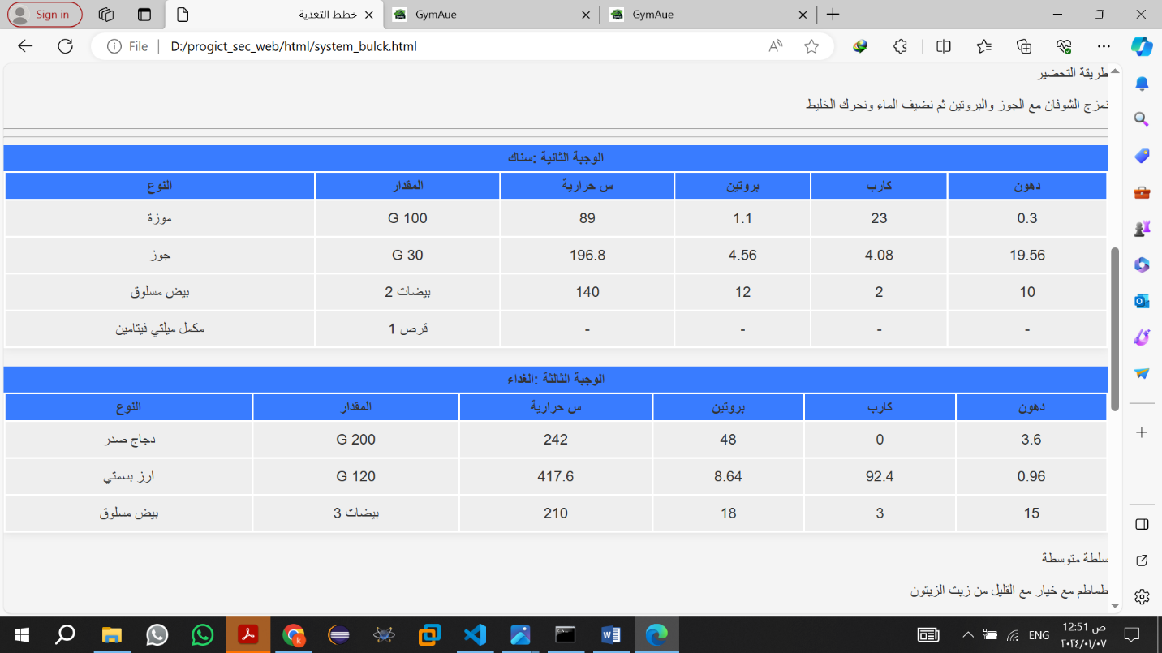

6 - Drying system 1

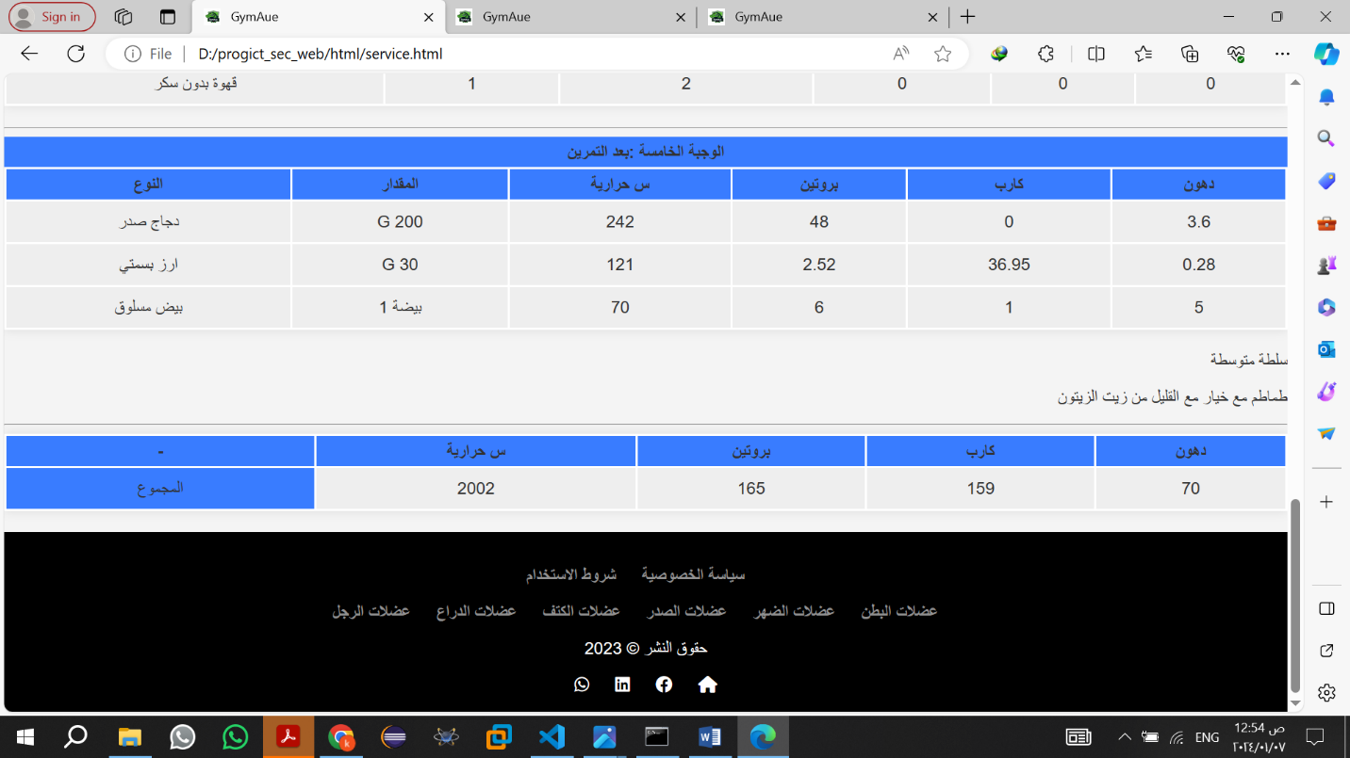

7- Drying system 2

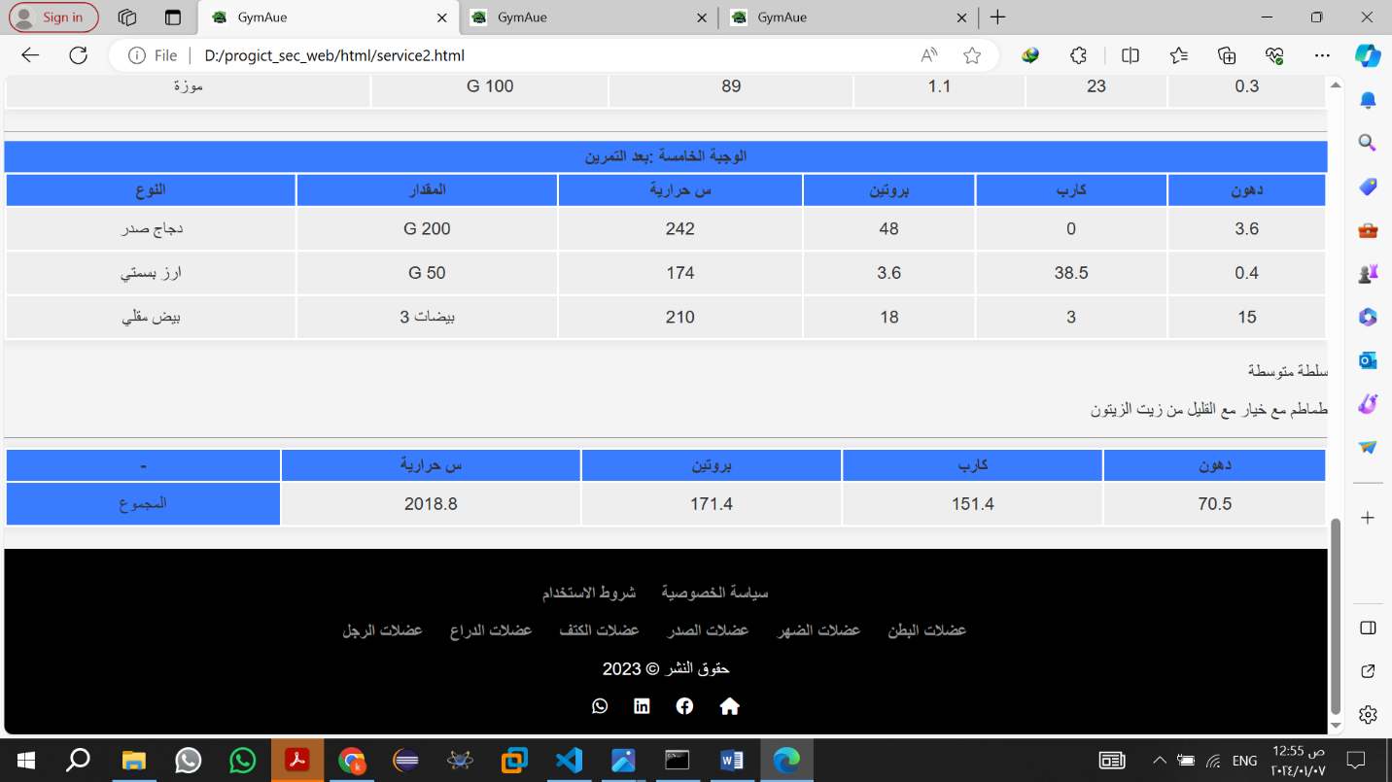

8- Protein sources

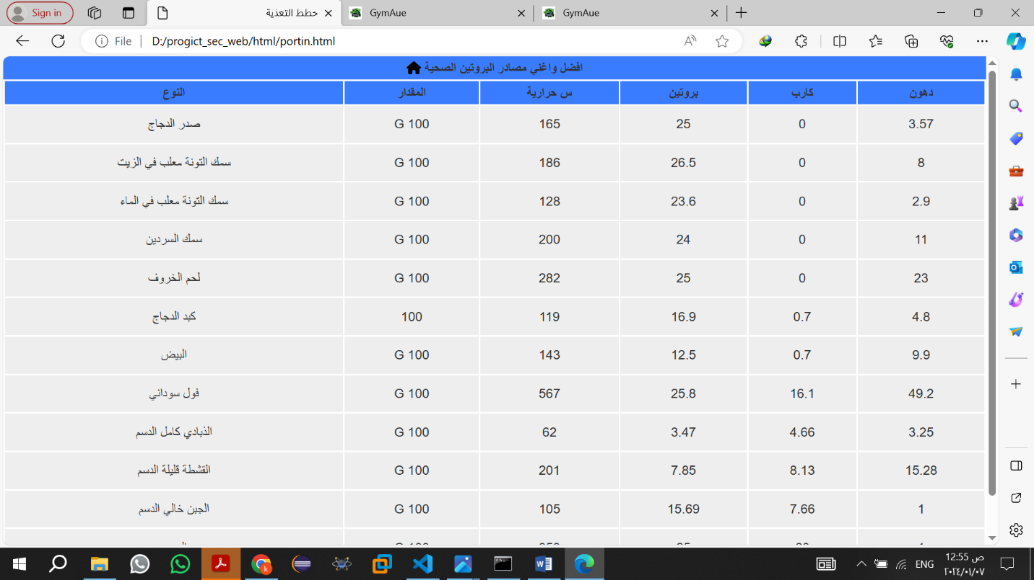

9- Sources of healthy fats

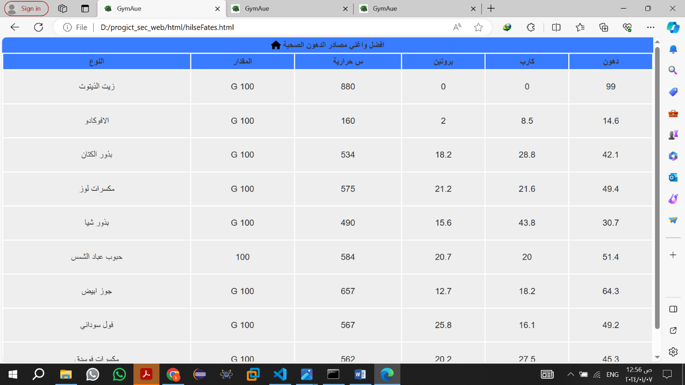

10- Sources of milk and eggs

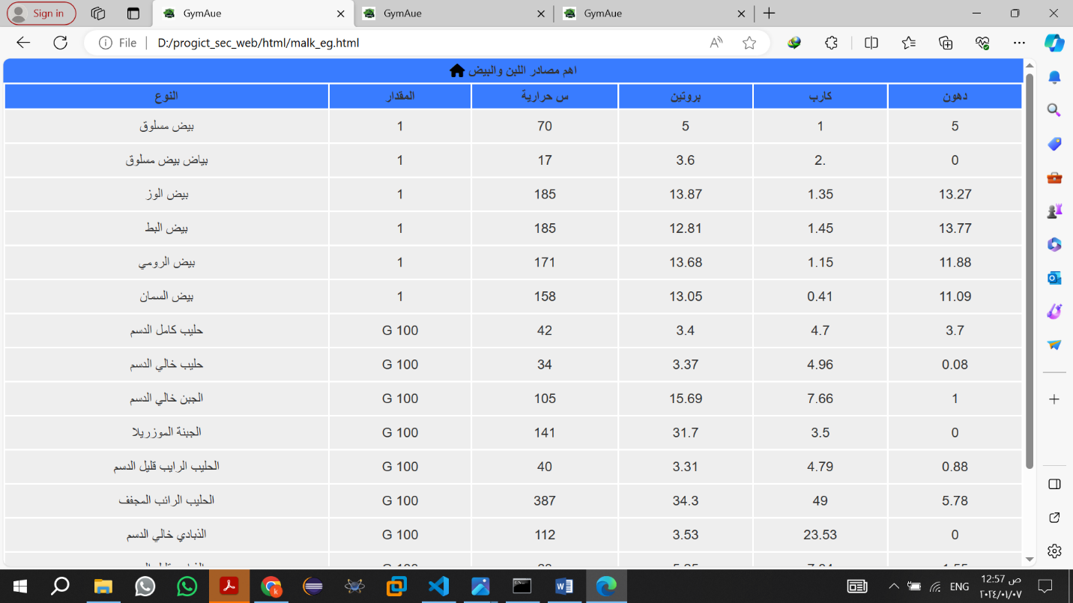

11- Sources of carbohydrates

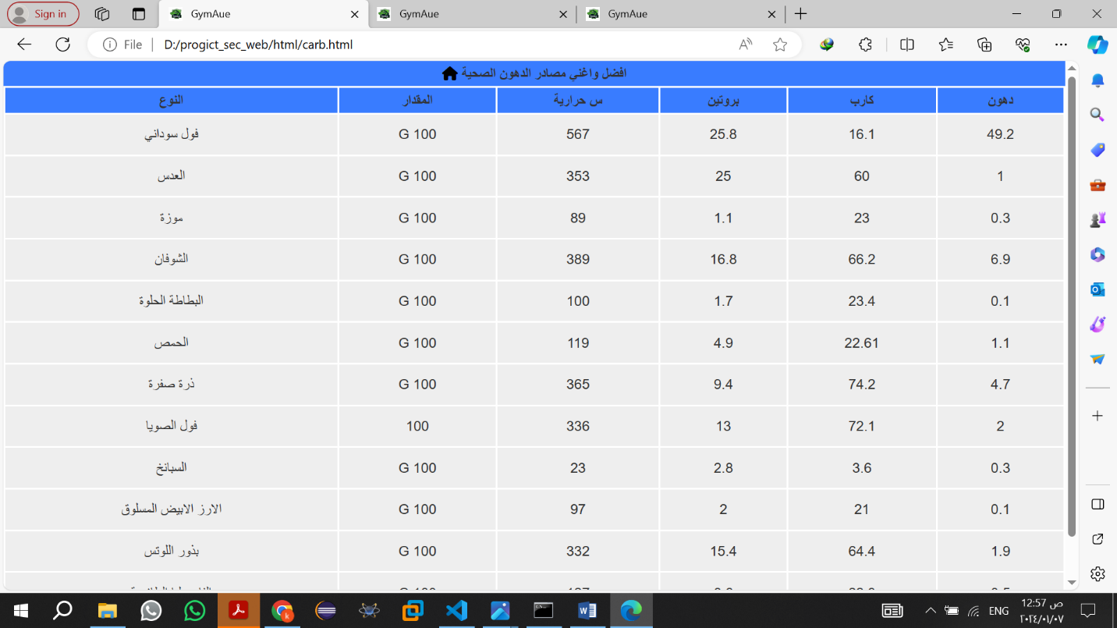

12- call us

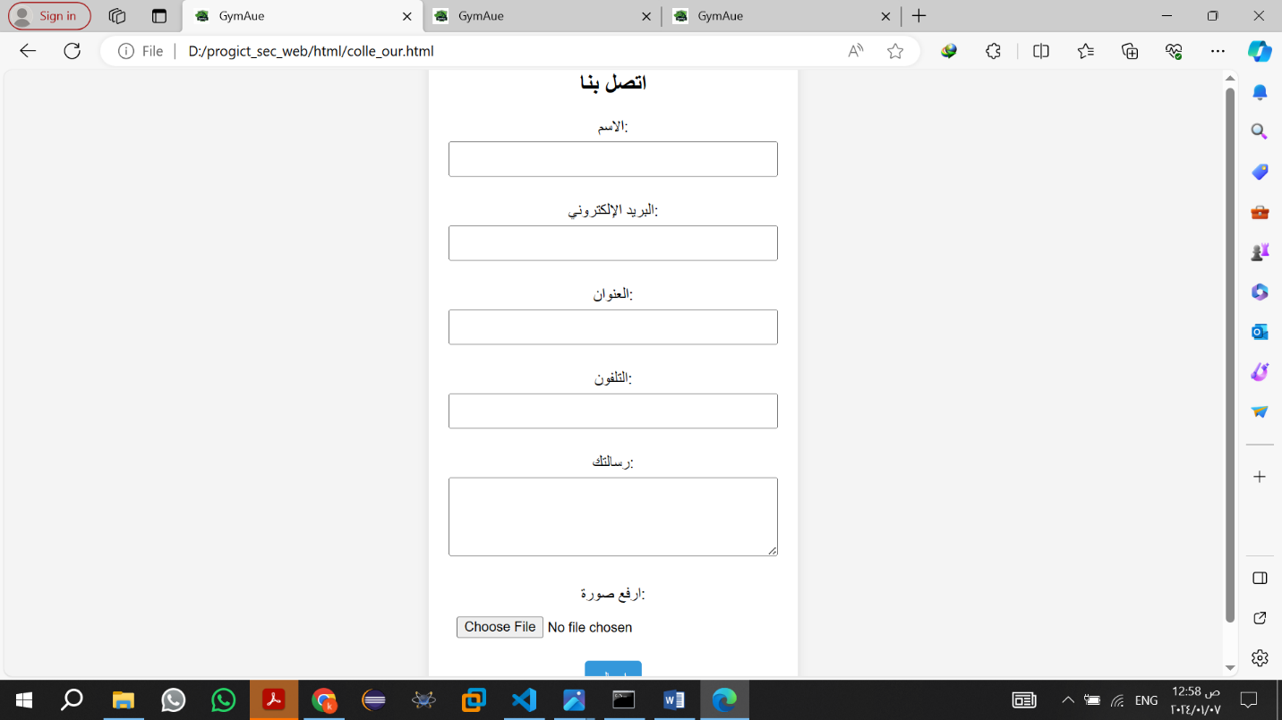

13- Create anew account

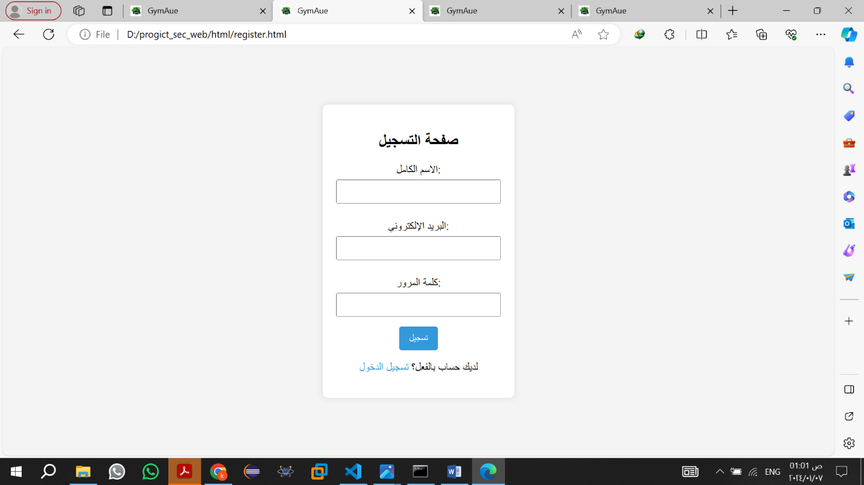

14- privacy policy

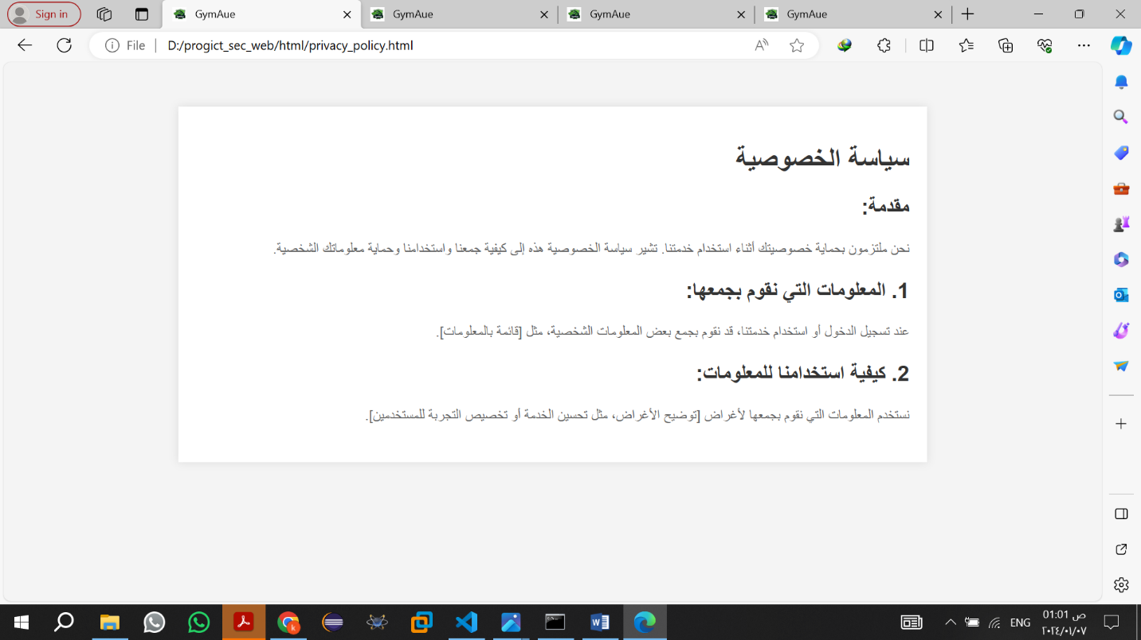

15- terms of use

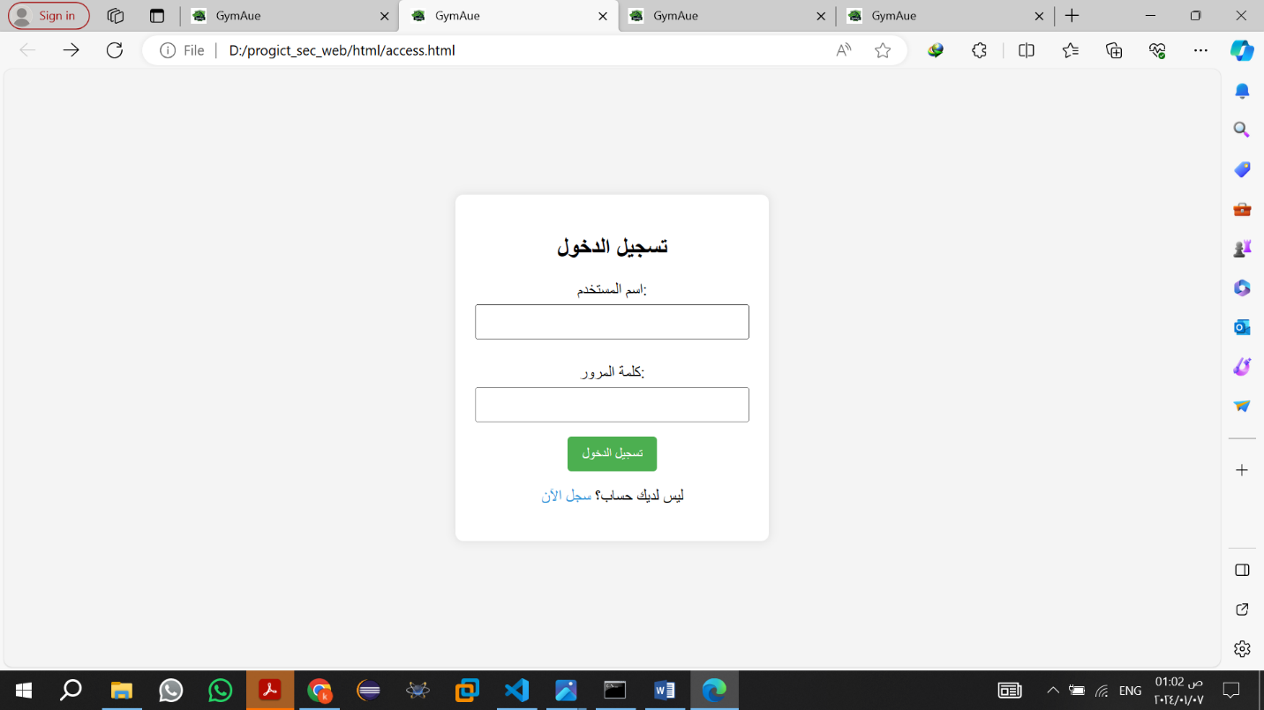

16- Abdominal muscles

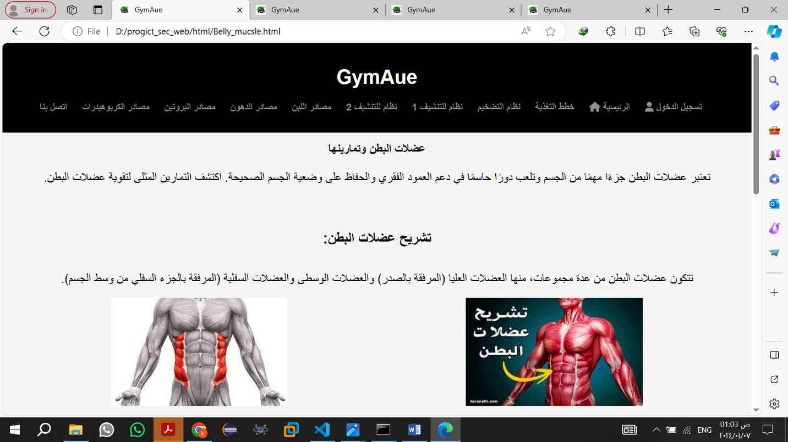

17- Back muscles

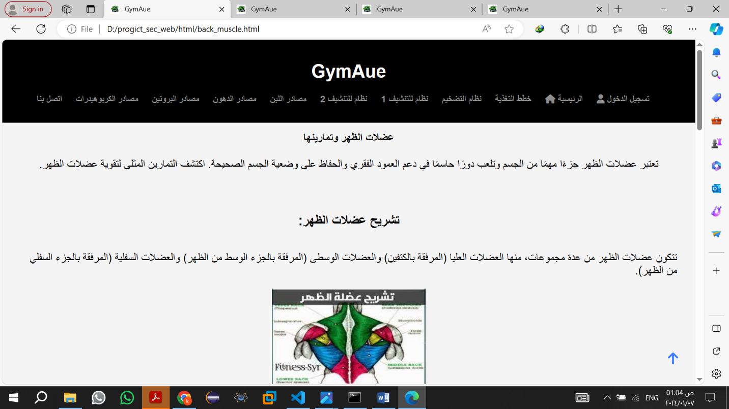

18- Chest muscles

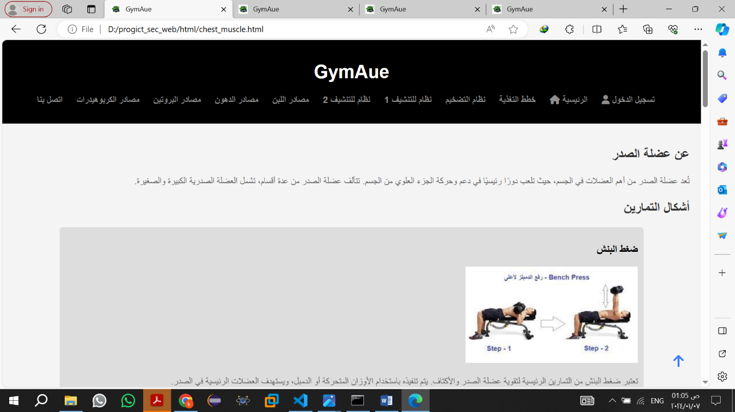

19- Shoulder muscles

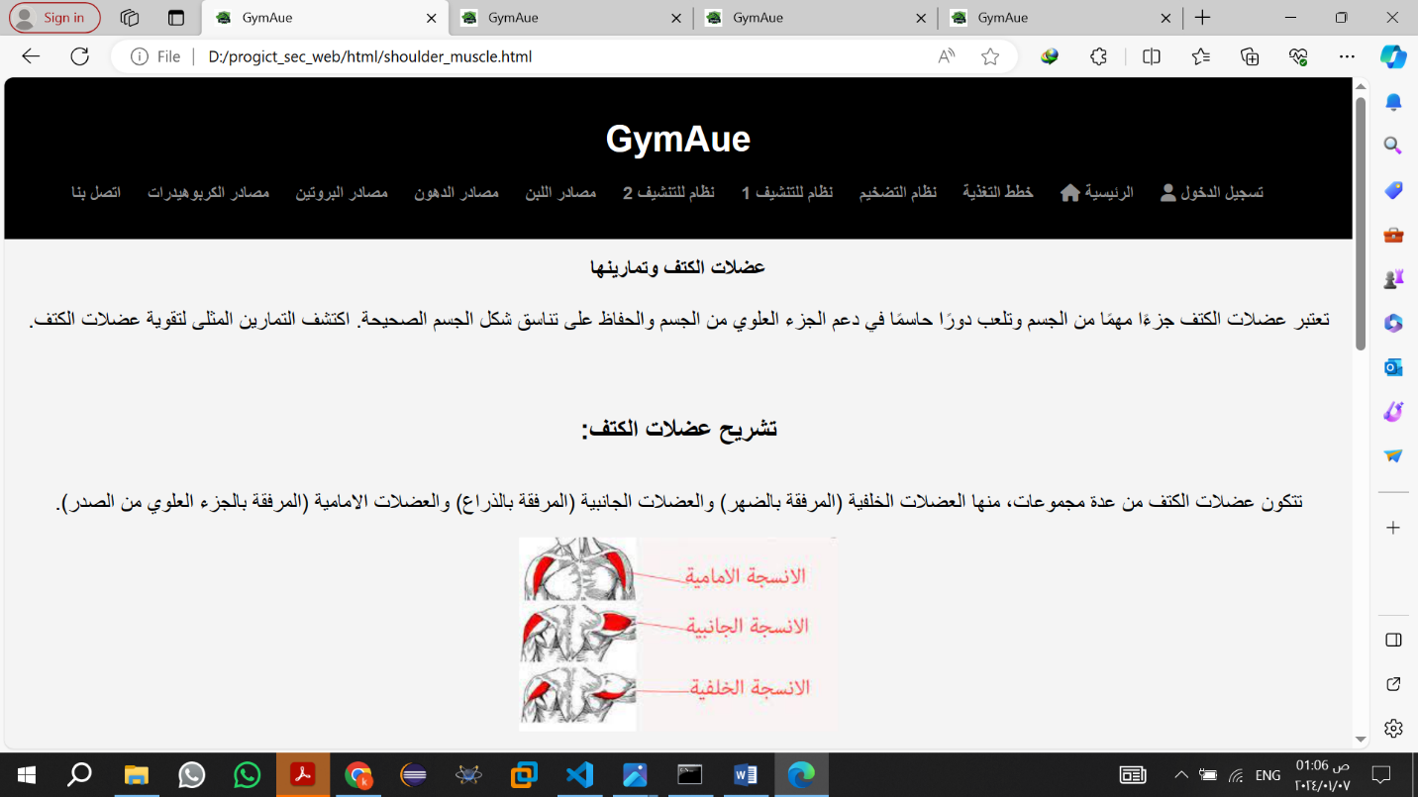

20- Arm muscles

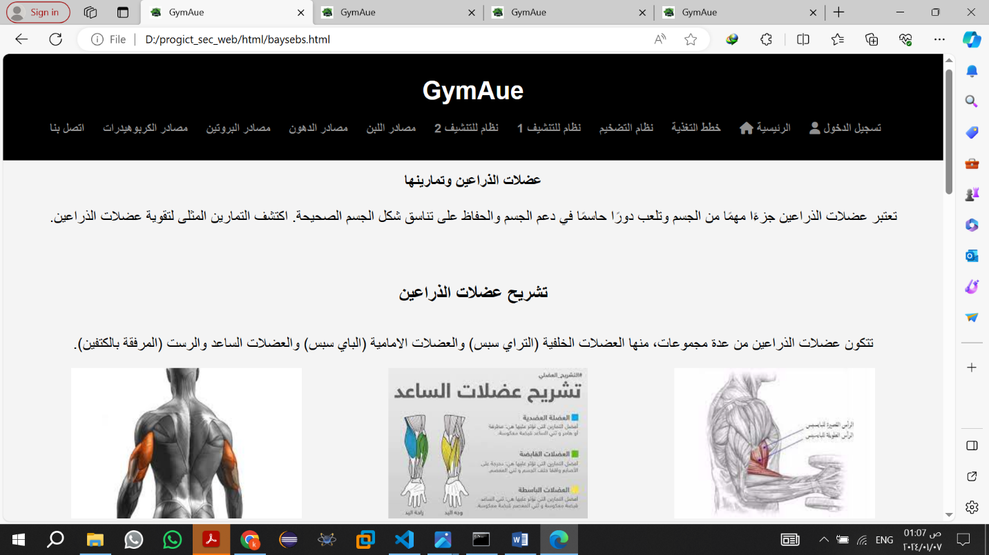

21- Leg muscles

